EXPERIMENT 2
Aim of the Session
To understand and implement SQL SELECT queries using various clauses such as WHERE, ORDER BY, GROUP BY, and HAVING for efficient retrieval, filtering, grouping, and analysis of data from relational database tables.

Objective of the Session
- Write SQL SELECT statements effectively
- Apply filtering conditions using the WHERE clause
- Sort query results using the ORDER BY clause
- Group records using the GROUP BY clause
- Filter grouped data using the HAVING clause
- Analyze data using aggregate functions such as COUNT(), SUM(), AVG(), MIN(), and MAX()

Practical / Experiment Steps
- Create an EMPLOYEE table with appropriate attributes
- Insert sample employee records into the table
- Filter employees based on salary conditions
- Calculate department-wise average salary
- Display only departments satisfying the given conditions
- Sort the final result in descending order of average salary

Procedure of the Experiment
- Start the system and log in to the computer.
- Open PostgreSQL using pgAdmin.
- Create or select the required database.
- Create the EMPLOYEE table using the CREATE TABLE command.
- Insert sample employee records using INSERT statements.
- Execute SQL queries using:
  - WHERE clause
  - GROUP BY clause
  - HAVING clause
  - ORDER BY clause
- Verify the output generated by the queries.
- Save the work and take screenshots of the execution results.

I/O Analysis (Input / Output Analysis)
Input Provided
- Employee details including:
  - Employee ID
  - Employee Name
  - Department
  - Salary
  - Joining Date
- SQL queries applying filtering, grouping, and sorting conditions
Output Generated
- Department names along with their average salary
- Display of only those departments where:
  - Employee salary is greater than 20,000
  - Average department salary is greater than 30,000
- Output sorted in descending order of average salary
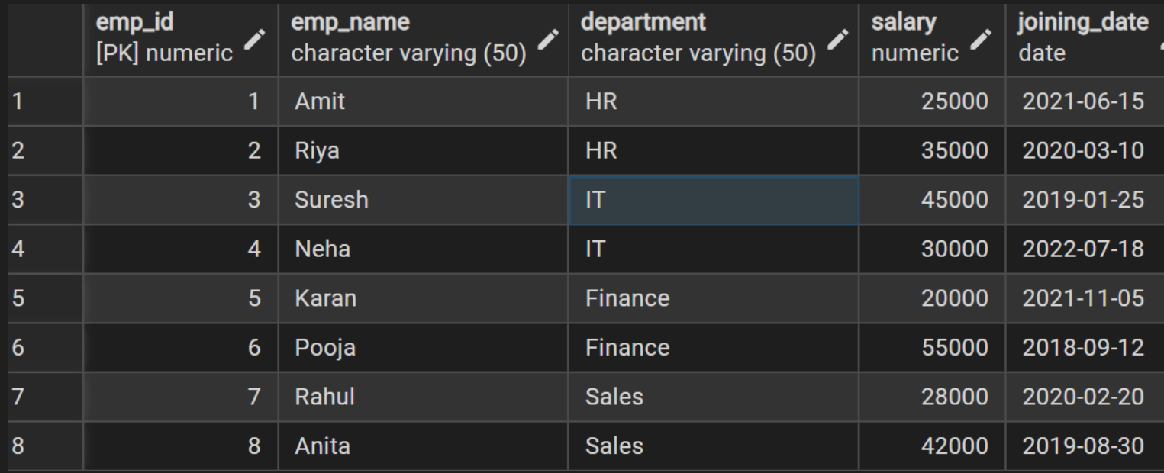
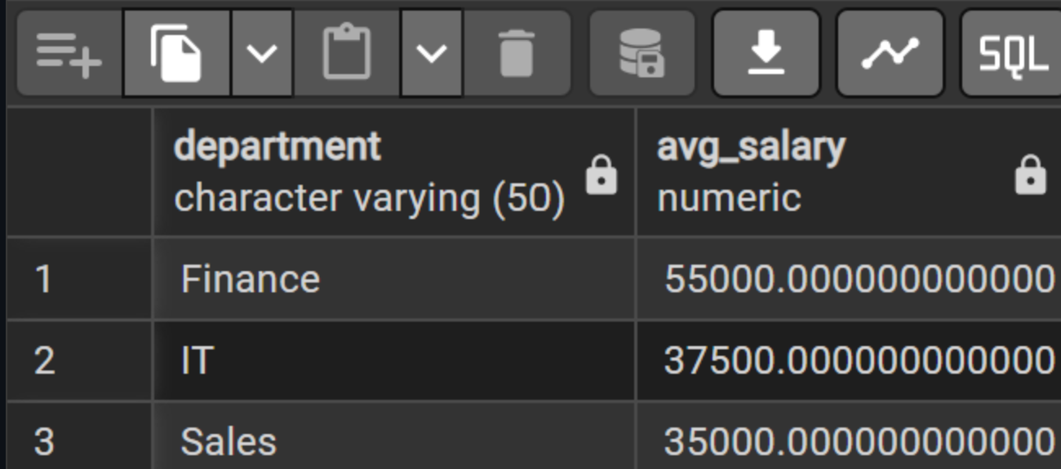

Learning Outcome
- How to filter records using the WHERE clause
- How to group records using the GROUP BY clause
- How to apply conditions on grouped data using the HAVING clause
- How to sort query results using the ORDER BY clause
- Practical use of aggregate functions for data analysis

